15.Bluetooth Communication between Two ESP 32(Practical).

**Sender ESP32 Code:**

#include <BluetoothSerial.h>

BluetoothSerial SerialBT;

void setup() {

  Serial.begin(115200);

  SerialBT.begin("ESP32_Sender"); // Bluetooth device name

}

void loop() {

  SerialBT.println("Hello from Sender");

  delay(1000);

}

**Receiver ESP32 Code:**

#include <BluetoothSerial.h>

BluetoothSerial SerialBT;

void setup() {

  Serial.begin(115200);

  SerialBT.begin("ESP32_Receiver"); // Bluetooth device name

}

void loop() {

  if (SerialBT.available()) {

    String incomingData = SerialBT.readString();

    Serial.println("Received: " + incomingData);

    // Add your logic for processing received data

  }

  delay(10);

}

Steps:

**Connecting ESP32 Bluetooth with PC**

As ESP32 Bluetooth is configured follow the steps to connect ESP32 Bluetooth with PC.

**Step 1:**Open Bluetooth settings in Windows:

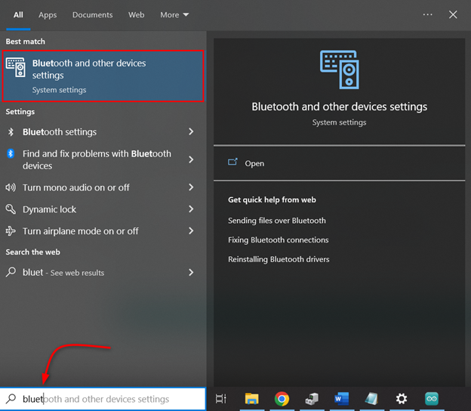

**Step 2:**Click **Add a Bluetooth Device**:

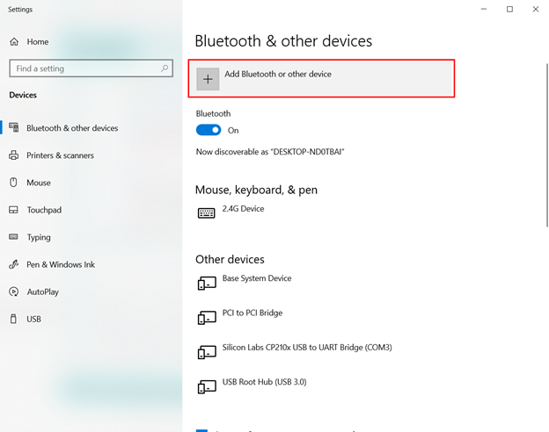

**Step 3:**Select **Bluetooth** device:

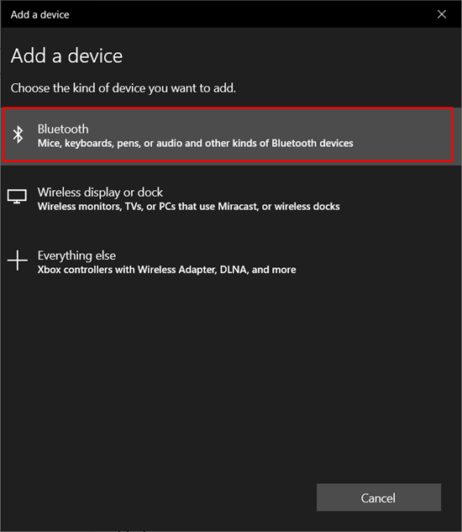

**Step 4:**Click **ESP32 Bluetooth**. Here you will see any name of ESP32 which you defined inside the Arduino code:

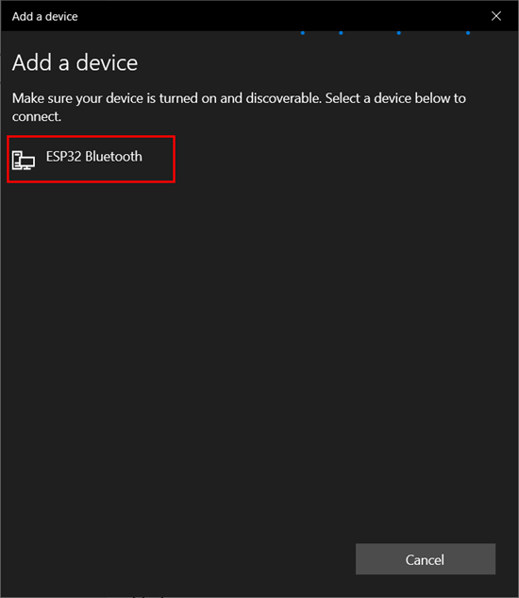

**Step 5:**Once the ESP32 Bluetooth is successfully connected below a message will appear:

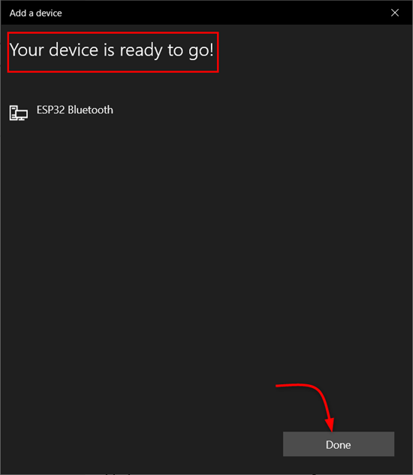

**Step 6:**In device manager we can see COM port for ESP32 Bluetooth. Knowing this COM port is important as it will help us to receive the data over the serial monitor in the Arduino IDE:

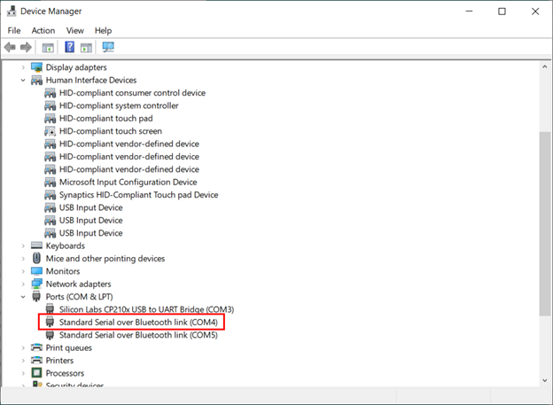

Now we have successfully connected ESP32 with PC over Bluetooth communication.

**Reading Serial Data over Bluetooth Communication**

To read serial data over Bluetooth first we have to disconnect the ESP32 from the PC so it will not establish any UART serial communication. After disconnecting we can verify it from the Device Manager.

The image shows ESP32 is disconnected from the PC.

**Note:**Remember to power ESP32 from any other PC or using the power adapter. This will help to remain ESP32 Bluetooth turned on.

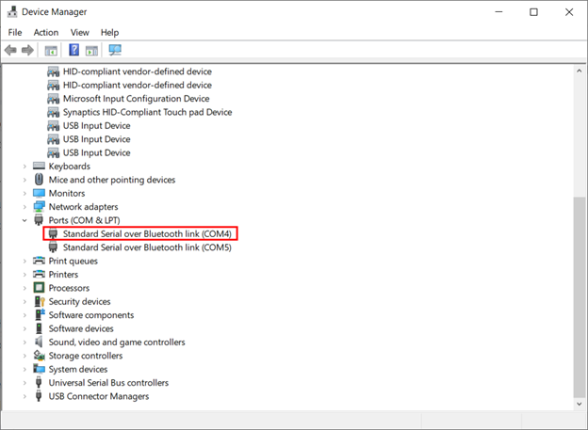

After disconnecting the ESP32 from the PC, open the Arduino IDE and select the COM port at which ESP32 Bluetooth is connected.

After selecting the right port, we can see the ESP32 is continuously transmitting the Hello World string over the serial monitor using Bluetooth communication.

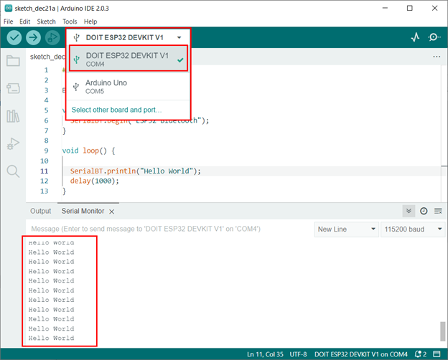

We have successfully received data using the Serial Bluetooth of ESP32.

15.Scanning of Wi-Fi Network using ESP 32(Skill)

#include <WiFi.h>

void setup() {

  Serial.begin(115200);

  // Set WiFi mode to station

  WiFi.mode(WIFI_STA);

  // Start scanning for networks

  int numNetworks = WiFi.scanNetworks();

  Serial.println("Found " + String(numNetworks) + " networks:");

  // Print details of each network

  for (int i = 0; i < numNetworks; ++i) {

    Serial.print(WiFi.SSID(i));

    Serial.print("\t(");

    Serial.print(WiFi.RSSI(i));

    Serial.print(") - ");

    Serial.print(WiFi.encryptionType(i));

    Serial.println();

  }

  Serial.println();

}

void loop() {

  // ... (Optional, additional functionality)

}

Output:

Found 7 networks:

Manu (-35) - 3

narsi (-59) - 3

KLH (-65) - 0

KLH (-76) - 0

KLH (-83) - 0

KLH (-83) - 0

KLH-E (-92) - 0